I affirm that I have carried out my academic endeavours with full academic honesty [Sol Ben-Ishay]

Project 2: Python Programming Competition

Sol Ben-Ishay

Questions

Question 1.

List top_20_forty_times contains 40 yard dash times for the three attempts by each of the top 20 fastest players at the 2021 NFL Combine. Unlike previous years, where players were only allowed two attempts, the NFL allowed players during 2021 an optional third attempt.

Although most players took advantage of this third attempt, many did not and some players therefore have values of 'N/A' for one of their attempts. Complete the function named get_average_times() that takes a nested list of times as input and returns a new list avg_forty_times containing the average times for each of the players in input. Use Python's built-in round() function that takes the form of round(value, # of decimal places) to round each of the average values in the new list to 2 decimal places. Print the output of your function called with top_20_forty_times in a separate print() call.

The nested list of times has already been loaded as a variable, top_20_forty_times, and is equal to: [[4.277, 4.317, 'N/A'], [4.323, 4.492, 4.357], [4.398, 4.445, 4.415], [4.335, 'N/A', 4.419], [4.266, 4.421, 4.248], [4.253, 4.374, 4.37], [4.353, 'N/A', 4.303], [4.292, 4.271, 4.307], [4.272, 4.355, 4.488], [4.288, 4.261, 4.386], [4.389, 4.453, 4.216], ['N/A', 4.368, 4.218], [4.42, 4.344, 4.374], [4.354, 4.326, 'N/A'], [4.287, 'N/A', 4.238], [4.328, 4.202, 4.422], [4.412, 4.289, 'N/A'], [4.285, 4.259, 'N/A'], [4.369, 4.446, 4.417], [4.286, 4.276, 4.234]].

As an example, if top_20_forty_times was equal to: [[3,5,4], [4,4,'N/A'], [3,4,5], [3,3,6], [4,5,5]], avg_top_20_forty_times should be equal to: [4, 4, 4, 4, 4.667].

top_20_forty_times = [[4.277, 4.317, 'N/A'], [4.323, 4.492, 4.357], [4.398, 4.445, 4.415], [4.335, 'N/A', 4.419], [4.266, 4.421, 4.248], [4.253, 4.374, 4.37], [4.353, 'N/A', 4.303], [4.292, 4.271, 4.307], [4.272, 4.355, 4.488], [4.288, 4.261, 4.386], [4.389, 4.453, 4.216], ['N/A', 4.368, 4.218], [4.42, 4.344, 4.374], [4.354, 4.326, 'N/A'], [4.287, 'N/A', 4.238], [4.328, 4.202, 4.422], [4.412, 4.289, 'N/A'], [4.285, 4.259, 'N/A'], [4.369, 4.446, 4.417], [4.286, 4.276, 4.234]]

Complete the function below:

def get_average_times(times_list):

avg_forty_times = []

...

...

Question 2.

Say I have two variables, a and b equal to string 'A' and integer 7. Even though it is obvious these two values aren't the same type, which of the following answers is a possible way to return a boolean that tests if the data type of these variables is equal?

A) a.kind = b.kind  
B) type(a) = type(b)  
C) data_type(a) = data_type(b)  
D) a.Type == b.Type  
E) type(a) == type(b)

Question 3.

String A = "I love computer science" is supposed to be the title of a book and therefore the L, C, and S should be capitalized? Which of the following is a possible way to capitalize the L, C, and S?

A) A.title()  
B) A.upper([2,7,16])  
C) A[0:2] + A[2].upper() + A[3:7] + A[7].upper() + A[8:16] + A[16].upper() + A[17:]  
D) A[2,7,16].toUpper()  
E) A and C

Question 4.

The function blender is defined as:

def blender(input):  
  input *= 20  
  input -= (input*2)  
  input /= input  
  return input

With 4 as the input, what will this function return?

A) 80  
B) 36  
C) 1  
D) 160  
E) 2

Answers

Answer 1. (The indentation wouldn't format properly so I had to screenshot the function)

#Initialize top_20_forty_times

top_20_forty_times = [[4.277, 4.317, 'N/A'], [4.323, 4.492, 4.357],

[4.398, 4.445, 4.415], [4.335, 'N/A', 4.419], [4.266, 4.421, 4.248],

[4.253, 4.374, 4.37], [4.353, 'N/A', 4.303], [4.292, 4.271, 4.307],

[4.272, 4.355, 4.488], [4.288, 4.261, 4.386], [4.389, 4.453, 4.216],

['N/A', 4.368, 4.218], [4.42, 4.344, 4.374], [4.354, 4.326, 'N/A'],

[4.287, 'N/A', 4.238], [4.328, 4.202, 4.422], [4.412, 4.289, 'N/A'],

[4.285, 4.259, 'N/A'], [4.369, 4.446, 4.417], [4.286, 4.276, 4.234]]

Complete the Function Below:

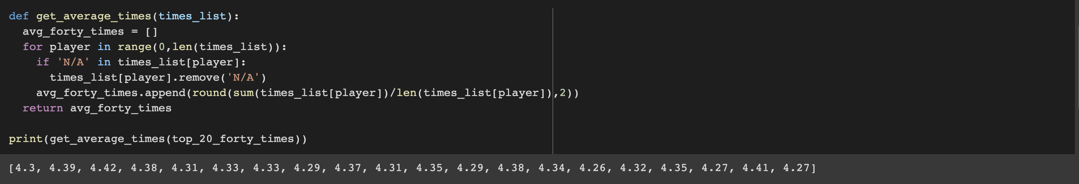

Answer 2. E

a = 'A'

b = 7

print(type(a) == type(b))

Output: False

Answer 3. E

test = "I love computer science"

print(test.title())

print(test[0:2] + test[2].upper() + test[3:7] + test[7].upper() + test[8:16] + test[16].upper() + test[17:])

Output: I Love Computer Science

I Love Computer Science

Answer 4. C

def blender(input):

input *= 20

input -= (input*2)

input /= input

return input

blender(4)

Output: 1.0